
Workflow & Requirements for Insurance
Table of Contents
Overview 2
Current Process Flow (Pipedrive) 3
Receive Insurance Job Request via Email 3
Create New Project 3
Next Activity 4
New Jobs > Installer Booked 4
Next Activity 4
Installer Booked > Customer Confirmation 4
Next Activity 4
Customer Confirmation > APS Jobs or Contractor Jobs 4
Next Activity 4
APS Jobs or Contractor Jobs > Review Job 5
Next Activity 5
Review Job > Report/Works Completed 5
Next Activity 5
Report/Works Completed > Completed 5
Proposal Creation (this step will remain in Pipedrive) 6
Create Proposal Deal (If Required) 6
Next Activity 6
Awaiting Proposal Creation > Proposal Created 6
Next Activity 6
Proposal Created > Issued and Awaiting Decision 6
Proposed Workflow (Odoo) 7
Rates (input into Odoo Items & Pricing module) 9
Electrical Works Report 9
Solar Report 9
Makesafe 9
Travel 9
Regional 9

Overview
AusPac Solar is being engaged by insurers to complete solar and electrical inspections, makesafe works and provide proposals for replacing solar systems where needed.
We are currently working with the following Insurers:
- KBA
- Rizon
The systems in use currently are below:
- Pipedrive – Project for works management and deal for proposal management if required
- Xero – purchase order / work order receipt management and invoice generation and issue on completion of works. If a replacement system is approved, management of invoicing for replacement works.
- Email – operations@auspacsolar.com.au – used to receive jobs and purchase orders, email completed inspection reports
- Email – Accounts@auspacsolar.com.au – Used to issue invoices against completed work, sent directly from Xero.

Current Process Flow (Pipedrive)
The process steps are summarised in the following diagram:
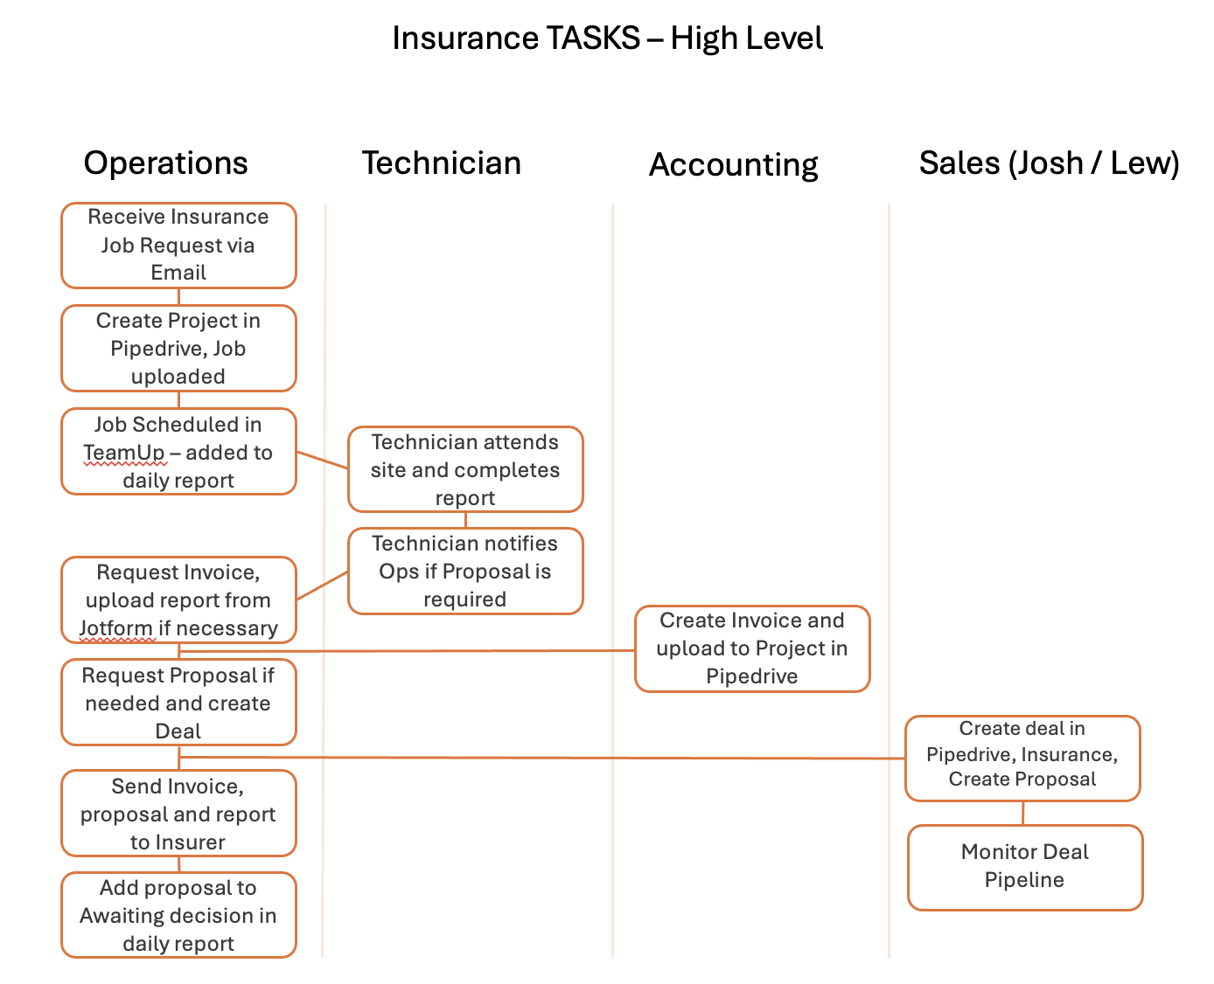

Receive Insurance Job Request via Email
The Operations team monitors the email account operations@auspacsolar.com.au for new jobs being allocated to AusPac Solar.
On receipt of the job, complete the following sub tasks:
- Ensure that the job includes a description of the service required
- Review Purchase order of job pack
- Check address and customer contact details are present
- Review location and determine if a quote is required. A quote is required under the following conditions:
  - Roof access is higher than 2 storey
  - There are multiple installations on different roof structures
  - The location is more than 50 kms from our Eagle Farm office
- In the event that a quote is required, generate the quote (Xero) using the parameters in the Rates section, send to the Insurer and await feedback.

Create New Project
Create a project in pipedrive in the Insurance pipeline using the “New Jobs” Phase. Ensure that the job details, customer contact details and purchase order or job are uploaded.
- The owner is the Operations Representative.

Next Activity
Create the following Activities, once completed, the project can be progressed to the next phase, “Installer Booked”:
- Identify the Installer, contact and secure a date and a price
- For AusPac bookings, update the TeamUp calendar, include the following details:
  - Date and Time of attendance, job notes from Insurer, Internal AusPac instructions, Link to the inspection report, customer name, address and contact phone number.

New Jobs > Installer Booked
Once the activity is completed, drag the project from “New Jobs” to “Installer Booked”.

Next Activity
Create the following Activities, once completed, the project can be progressed to the next phase, “Installer Booked”:
- Contact the customer and confirm the date

Installer Booked > Customer Confirmation
Once the previous activity is completed, drag the project from “Installer Booked” to “Customer Confirmation”.

Next Activity
Create the following Activities, once completed, the project can be progressed to the next phase, “Customer Confirmation”:
- Confirm with Installer that the Customer date is set

Customer Confirmation > APS Jobs or Contractor Jobs
Once the previous activity is completed, drag the project from “Customer Confirmation” to either “APS Jobs” or “Contractor Jobs”.

Next Activity
Create the following Activities, once completed, the project can be progressed to the next phase, “APS Jobs” or “Contractor Jobs”:
- Installer to complete the inspection report
- Determine if a proposal is required for a replacement of the solar system
- If a proposal is required for a replacement of the solar system, create the following activity:
  - Create a new pipedrive deal in the Insurance pipeline

APS Jobs or Contractor Jobs > Review Job
Once the previous activity is completed, drag the project from “APS Jobs” or “Contractor Jobs” to “Review Job”.

Next Activity
Create the following Activities, once completed, the project can be progressed to the next phase, “Review Job”:
- Review the inspection report for completion
- Load the inspection report into the project as a file
- Request an invoice to be raised.

Review Job > Report/Works Completed
Once the above activities are completed the job can be moved from “Review Job” to “Report/Works Completed”.

Next Activity
Create the following Activities, once completed, the project can be progressed to “Completed”:
- Send Invoice to Insurer
- Send Inspection Report to Insurer if using AusPac jotform
- Send Proposal to insurer if required

Report/Works Completed > Completed
Once the previous activities are completed, the job can be marked “Completed”.

Proposal Creation (will remain in Pipedrive/OpenSolar)

Create Proposal Deal (If Required)
Navigate to Deals in pipedrive and select the “Insurance” pipeline.
Insert the contact details for the Insurer and the address and site details for the customer site.
Enter the link to the project.
Assign the deal to Lewis Fleming or Joshua Fleming.

Next Activity
Create the following activity:
- Create Proposal, assign to Lewis Fleming or Joshua Fleming

Awaiting Proposal Creation > Proposal Created
Once the above activity is completed and the proposal is created and uploaded to the deal, the deal can be moved to “Proposal Created”.

Next Activity
Create the following activity:
- Issue proposal to Insurer

Proposal Created > Issued and Awaiting Decision
Once the above activity is completed the proposal can be moved from “Proposal Created” to “Issues and Awaiting Decision”

Proposed Workflow (Odoo)

Step | Status | Notes
- Receive insurance inspection request via email (includes PDF attachments)
Note - might explore using a public job submission link or portal access in future, but requests will come via email for now

- Create new Job in Odoo, select Type as ‘Inspection’ or ‘Make Safe’ or ‘Inspection & Make Safe’. | Ready to Schedule | - To move to Assigned (Pending Date), complete: Installer (Company).  - Keep Hold Actions, Scheduling Actions and Cancel
- Assign an Installer Company  - For AusPac bookings – add job to TeamUp calendar (current state) or leverage Odoo Calendar (future state)  - For contractor bookings - Contact the contractor and confirm a date and price | Assigned (Pending Date) | - To move to Assigned (Pending Customer), complete: Installation Date.  - Keep Hold Actions, Scheduling Actions and Cancel
- Contact customer to confirm inspection date | Assigned (Pending Customer) | - To move to Pre-Inspection, complete: Customer Confirmation.  - Keep Hold Actions, Scheduling Actions and Cancel
- Advise Installer and Insurer of confirmed inspection date (leverage notification rules)  - Generate Work Order – leverage current state format, we just need somewhere to track the allocated Rates for each inspection as outlined in Rates section | Pre-Inspection | - Keep Hold Actions, Scheduling Actions and Cancel
- Installer advises inspection is complete | Inspection in Progress | - Keep Hold Actions, Scheduling Actions and Cancel
- Review steps  - Confirm inspection reports are complete (external to Odoo)  - If proposal required, create Deal in Pipedrive>OpenSolar (currently manual but can explore integration to PD in future)  - Raise invoice in Xero (currently manual but can explore integration to Xero in future. Can leverage notification rules current state) | Post-Inspection Review | - Keep Hold Actions and Cancel
- Finalise steps  - Email PDF inspection report and OpenSolar proposal (if required) to insurer (can we send manual emails from Odoo or can they trigger via notification rules?) | Finalisation
- Mark Complete | Completed

Rates (input into Odoo Items & Pricing module)
AusPac Solar Inspection rates are detailed below.

Electrical Works Report
This report does not require the Electrician to carry our any roof work so is a lower cost than the Solar report
$270 + GST ($150 for tech + $120 callout)

Solar Report
$350 + GST

Makesafe
$150 per hour per tech (min 1 hour) + $120 callout

Travel
Per kilometre charge of $1.50 where the site is over 50km from our office:
- 41 Lavarack Ave, Eagle Farm
- 90 Raglan Street, Roma

Regional
In addition to the travel charges, we also charge an additional fee for inspections that are over 100 kilometres from our office. This fee is $200 above existing inspection rates.
Where the inspection site is 100 kilometres or more from our office, a proposal must be submitted to the insurer.

